Module 1
  - Explain the benefits of using Flutter over other cross-platform frameworks.
  - Single Codebase (Write Once, Run Everywhere)

With Flutter, you write one code and it works on:

Android
iOS
Web
Desktop
  - Huge Widget Library

In Flutter, everything is a widget:

Text
Image
Layout
Button and etc...
2. Describe the role of Dart in Flutter. What are its advantages for mobile development?
Dart is the backbone of everything you build.
Role of Dart
1. Fast Execution
2. Simple & Clean Syntax
3. Standard Library
4. Backed by Google
3. Outline the steps to set up a Flutter development environment
Step 1: Download Flutter SDK
Download the Flutter SDK from the official website.
Step 2: Extract the SDK
Unzip the downloaded file.
Place it in a fixed location
Step 3: Set System Path
Open Environment Variables
Add the path of the Flutter bin folder.
Step 4: Install Code Editor
Install a code editor such as:
Visual Studio Code
Android Studio
After installing:

Add Flutter extension
Dart plugin
Step 5: Set Up Android Platform
Open Android Studio
Use SDK Manager to install:
Android SDK
Command-line tools
Android Virtual Device (AVD)
Step 6: Verify Installation

Open terminal and run:flutter doctor
4. Describe the basic Flutter app structure, explaining main.dart, the main function, andthewidget tree.
1. main.dart (Entry Point of App)
-> main.dart is the starting file of every Flutter app
-> Located inside: lib/main.dart
->It is the first file that runs when your app starts

2. main() Function

Every Flutter app starts executing from the main() function.
main() starts the app and shows the first screen.
3. Widget Tree (Core Concept)

Flutter UI is made of widgets arranged in a tree structure.
MyApp
MaterialApp
Scaffold
AppBar
Text
Body
Center
Text
Set up the Flutter development environment on your system and verify installation withflutter doctor.
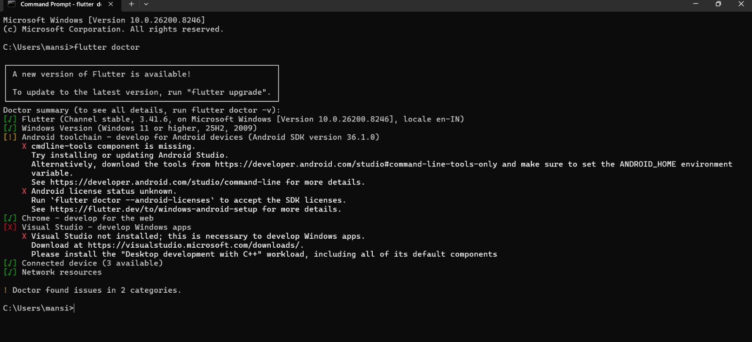
Create a new Flutter project and customize it to display a personalized “Hello, World!” message with your name

import 'package:flutter/material.dart';

void main() {
runApp(MyApp());
}

class MyApp extends StatelessWidget {
@override
Widget build(BuildContext context) {
return MaterialApp(
debugShowCheckedModeBanner: false,
home: Scaffold(
appBar: AppBar(
title: Text("My First Flutter App"),
centerTitle: true,
),
body: Center(
child: Text(
"Hello, World! 👋\nI am Mansi Raval",
textAlign: TextAlign.center,
style: TextStyle(
fontSize: 24,
fontWeight: FontWeight.bold,
color: Colors.blue,
),
),
),
),
);
}
}

Customize the app by adding a background color and using different text styles (font, size, color) for the welcome message.

import 'package:flutter/material.dart';

void main() {
runApp(MyApp());
}

class MyApp extends StatelessWidget {
@override
Widget build(BuildContext context) {
return MaterialApp(
home: Scaffold(
backgroundColor: Colors.yellow.shade100,
appBar: Apar(
title: Text("Simple App"),
),
body: Center(
child: Text(
"Hello, World!\nI am Mansi",
textAlign: TextAlign.center,
style: TextStyle(
fontSize: 24,
color: Colors.blue,
),
),
),
),
);
}
}

